  
 **CSE231  
 SEC: 06  
  
 Project**   
 Seven-Segment Display  
 on  
 BABAFAFA  
  
 **Submitted to:** Dr Mohammad Monirujjaman Khan  
  
  
 **Group Members:**  
 1. Kazi Mahbub Jamil 1921626042  
 2. Mahinur Sazib Sristy 192105504

3. Md. Sihab Bhuiyan 1912403642  
 4. Md. Adib Sadman 1921050042  
  
  
 **Written By :**  
 Kazi Mahbub Jamil  
  
  
   
 **Date:** 1 Jan,2021

Table Of Content:  
  
   
1. Introduction  
2. Encoder & Decoder  
3. Seven-Segment Display  
4. Truth Table  
5. Derived Equation using SOP  
6. K-map & Circuit Diagram  
7. Logisim  
8. Conclusion

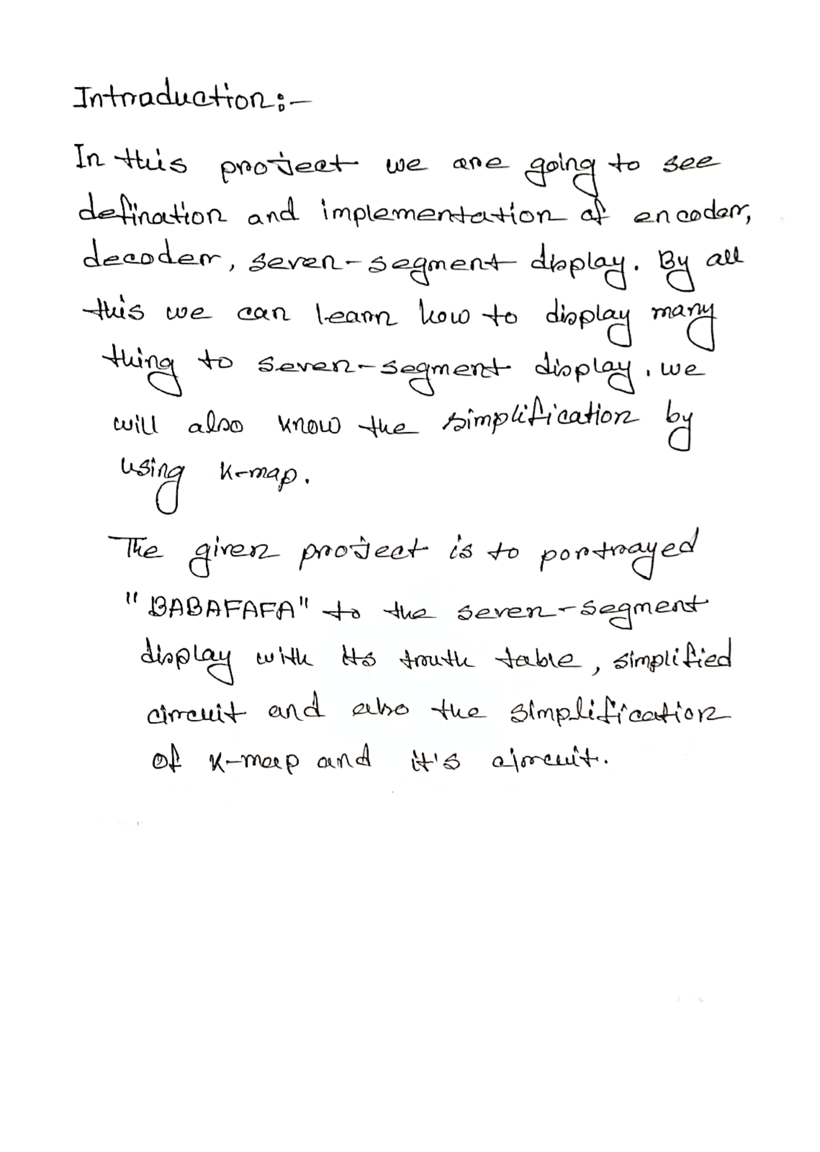

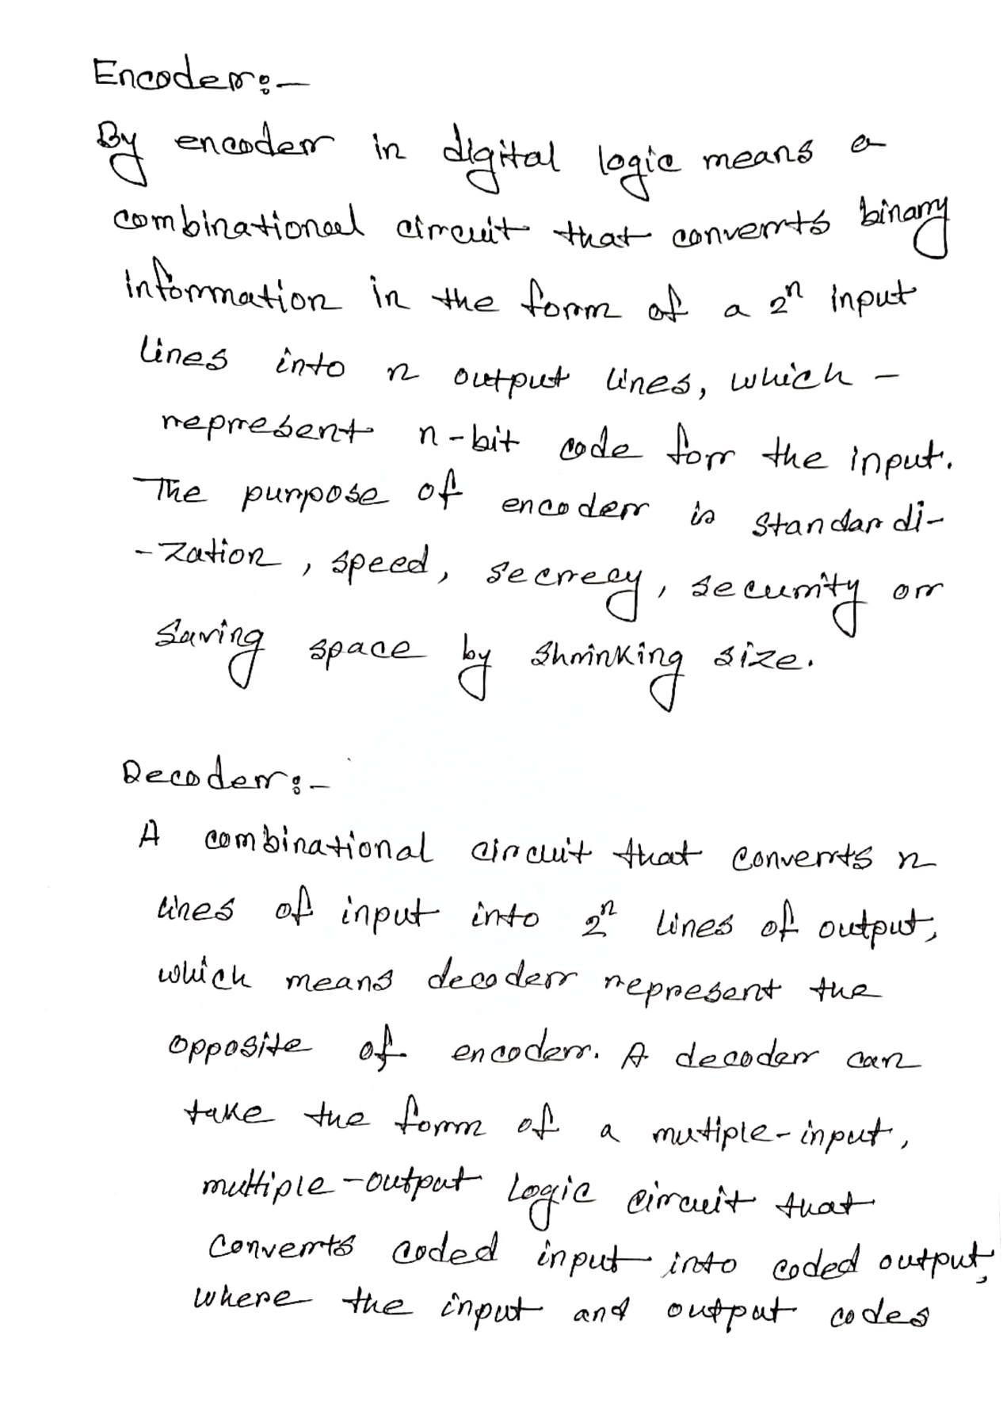  
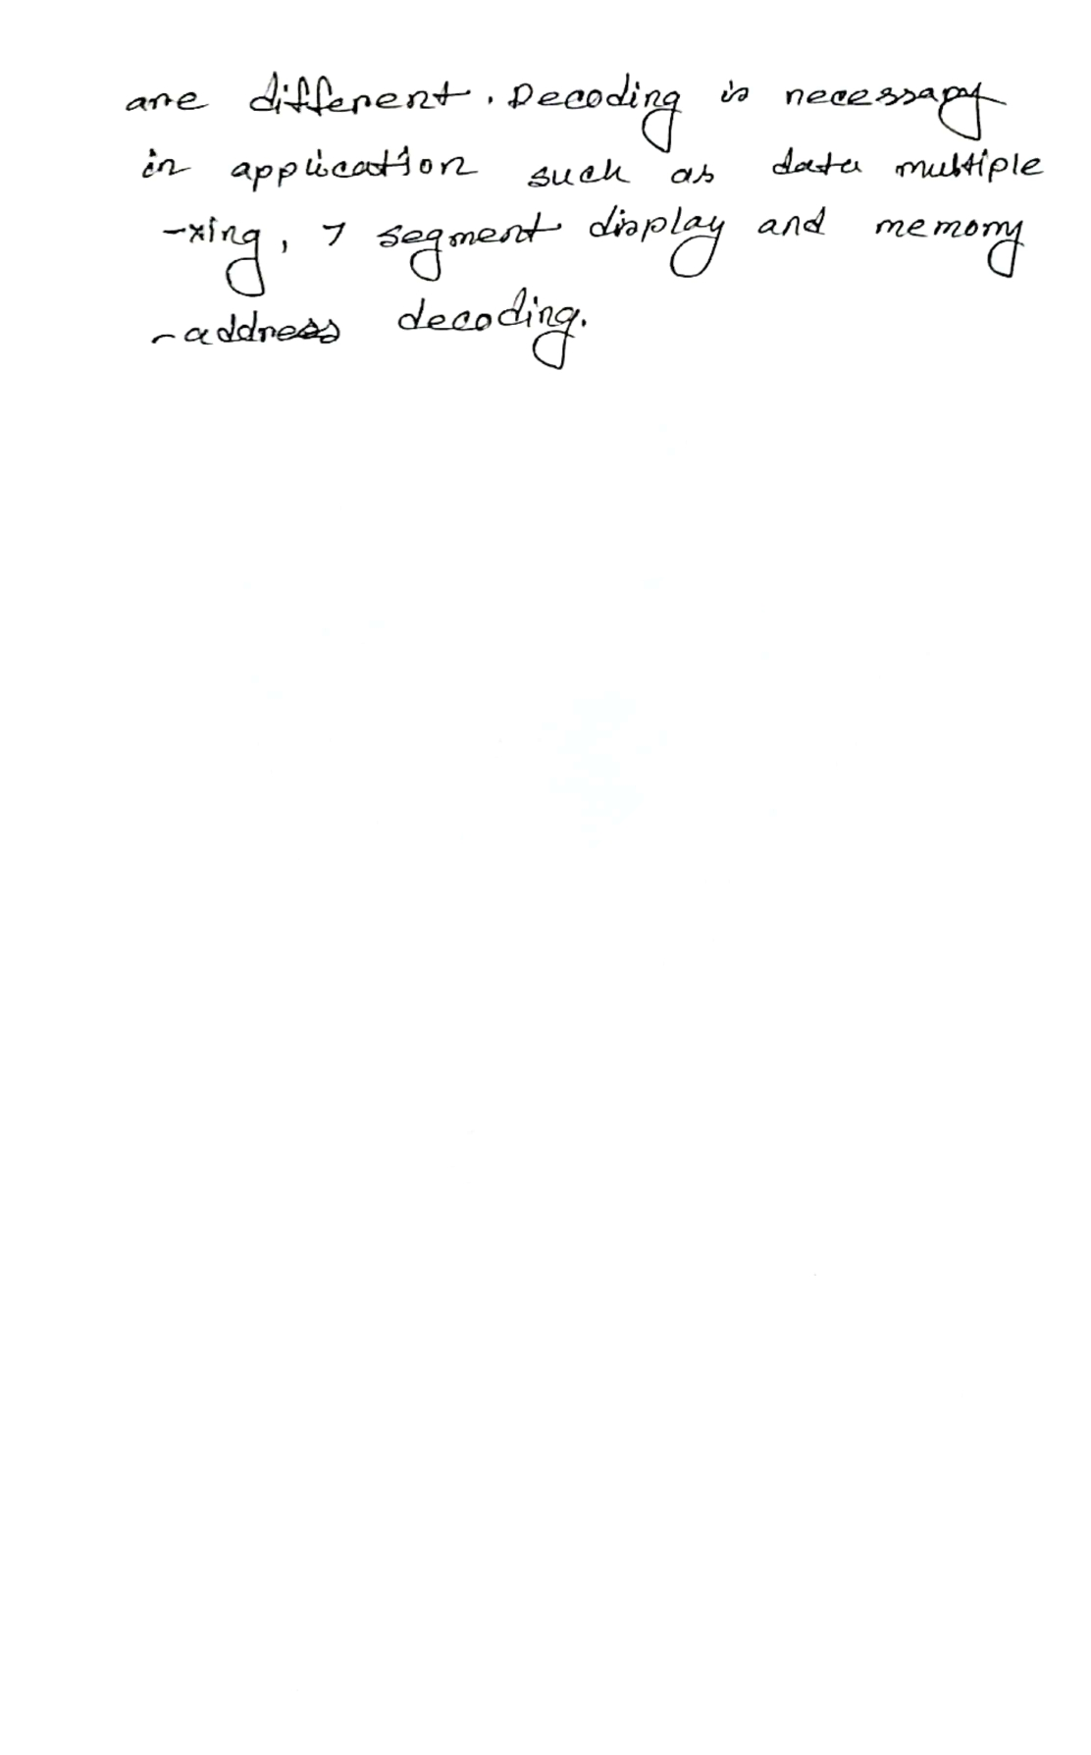  
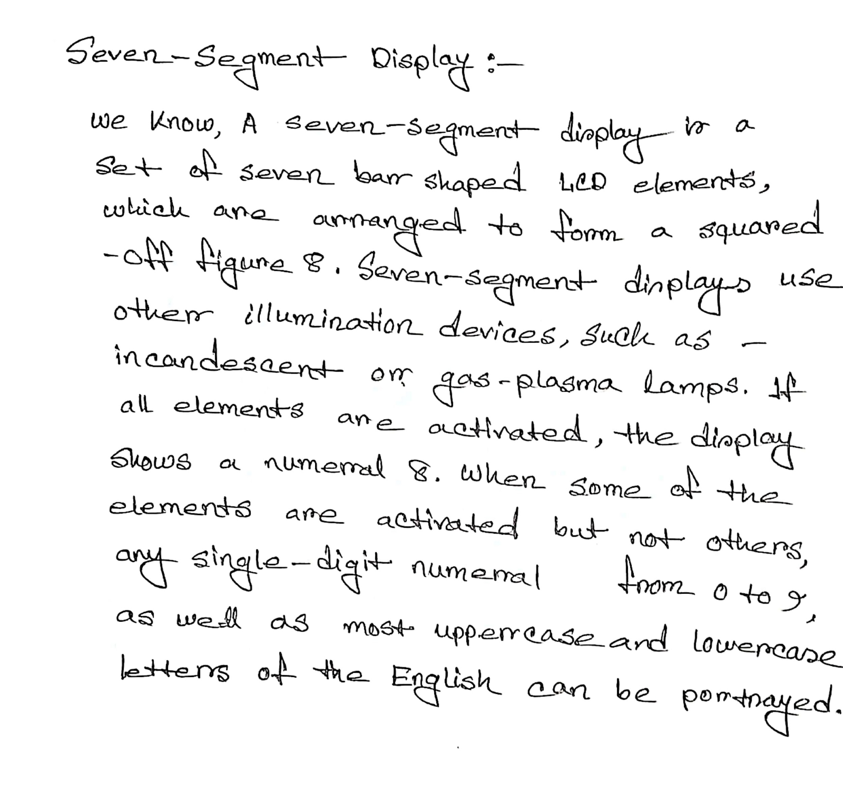  
  
  
  
  
  
  
  
  
  
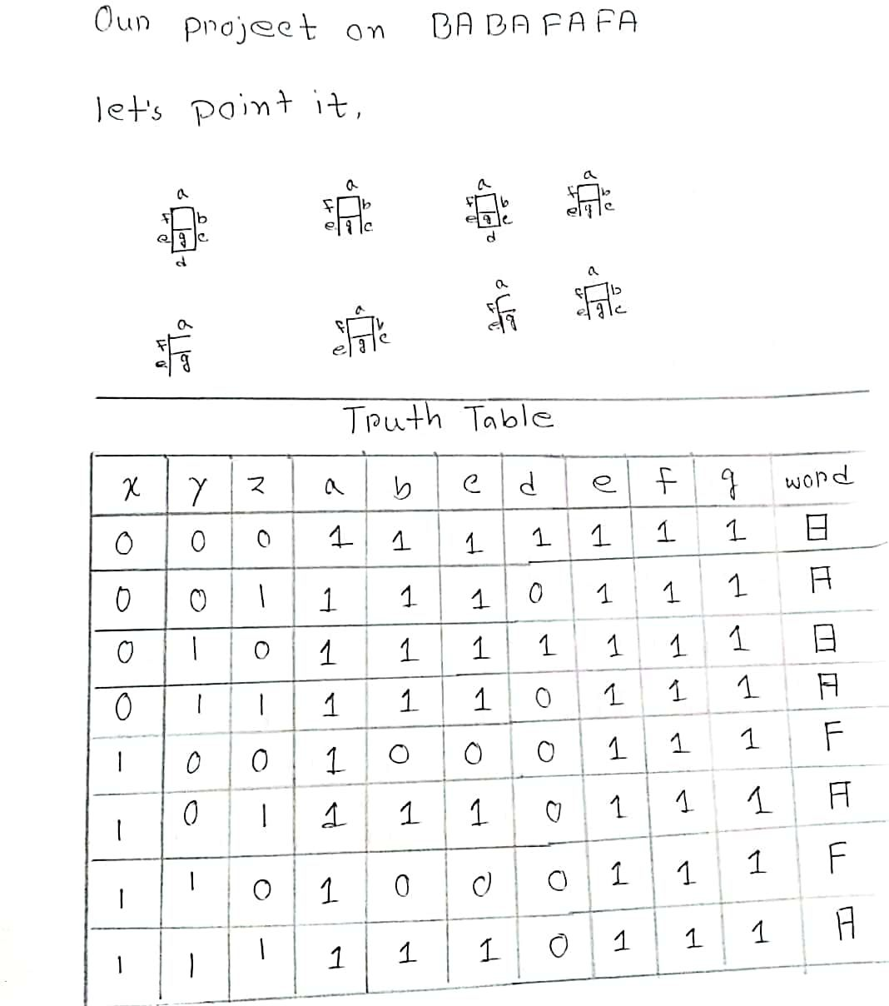  
  
  
  
  
  
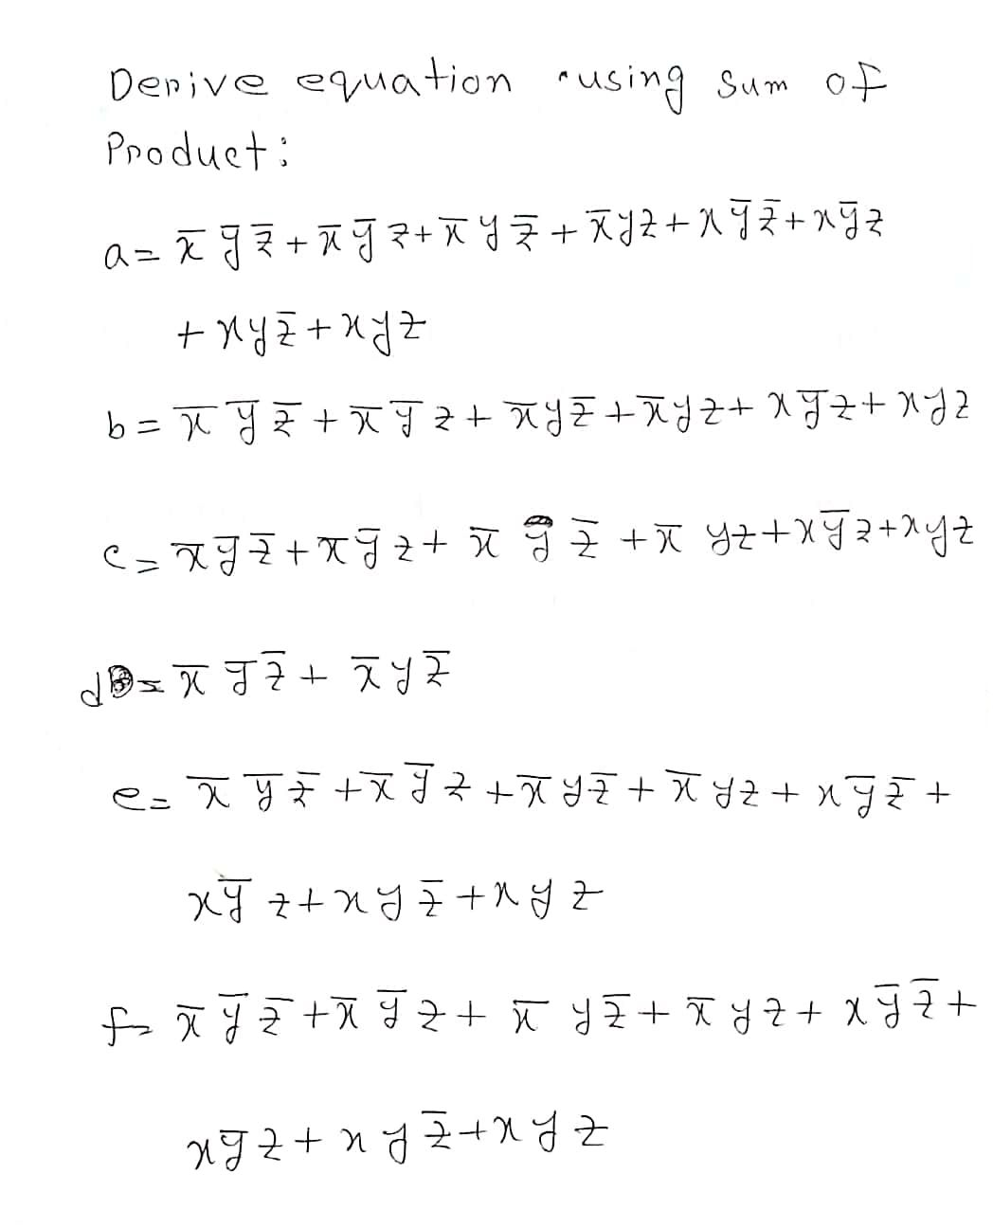  
  
  
  
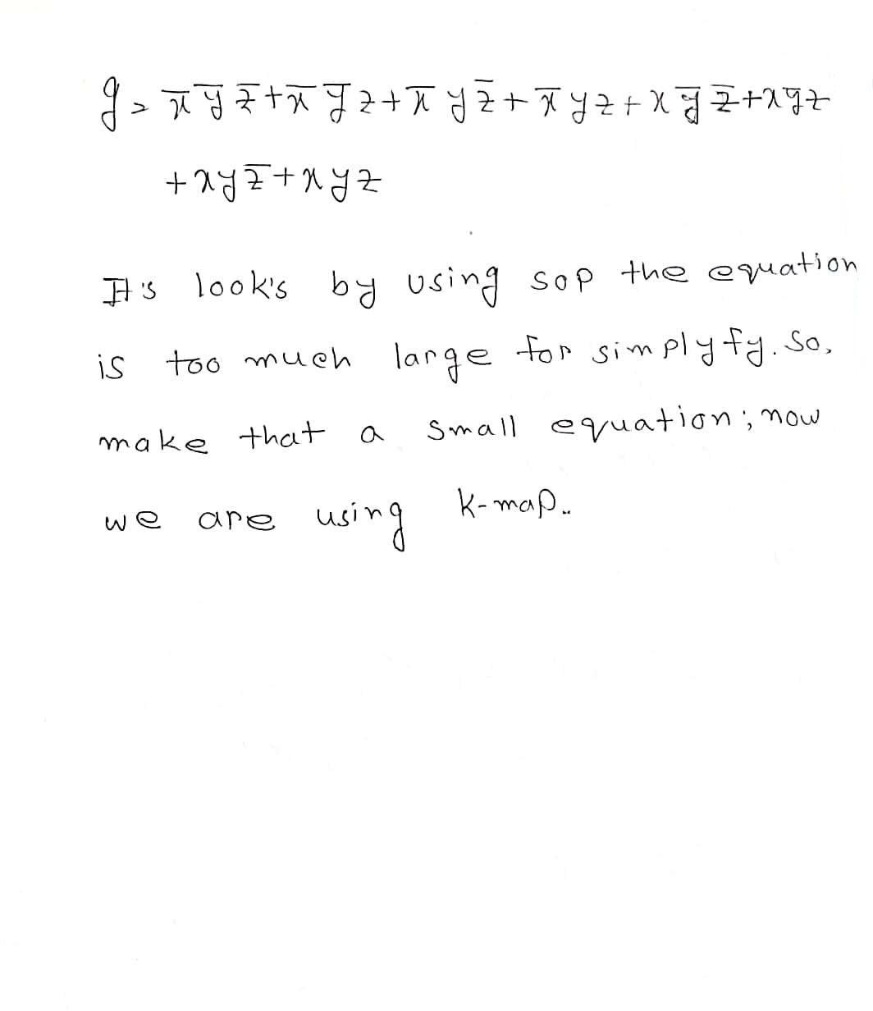  
  
  
  
  
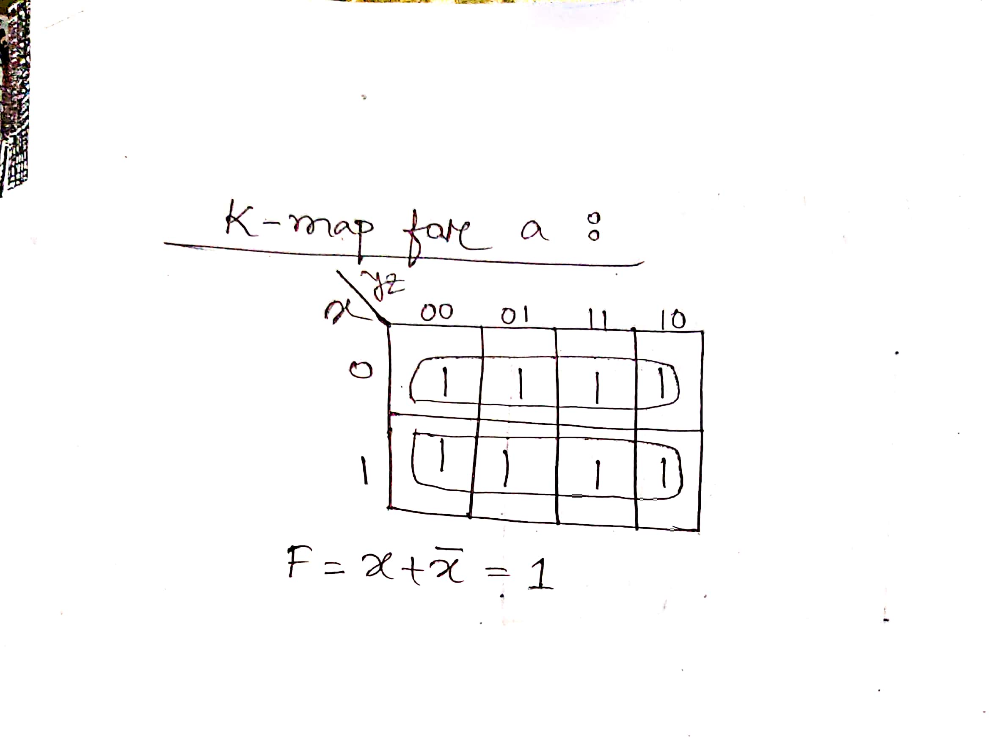  
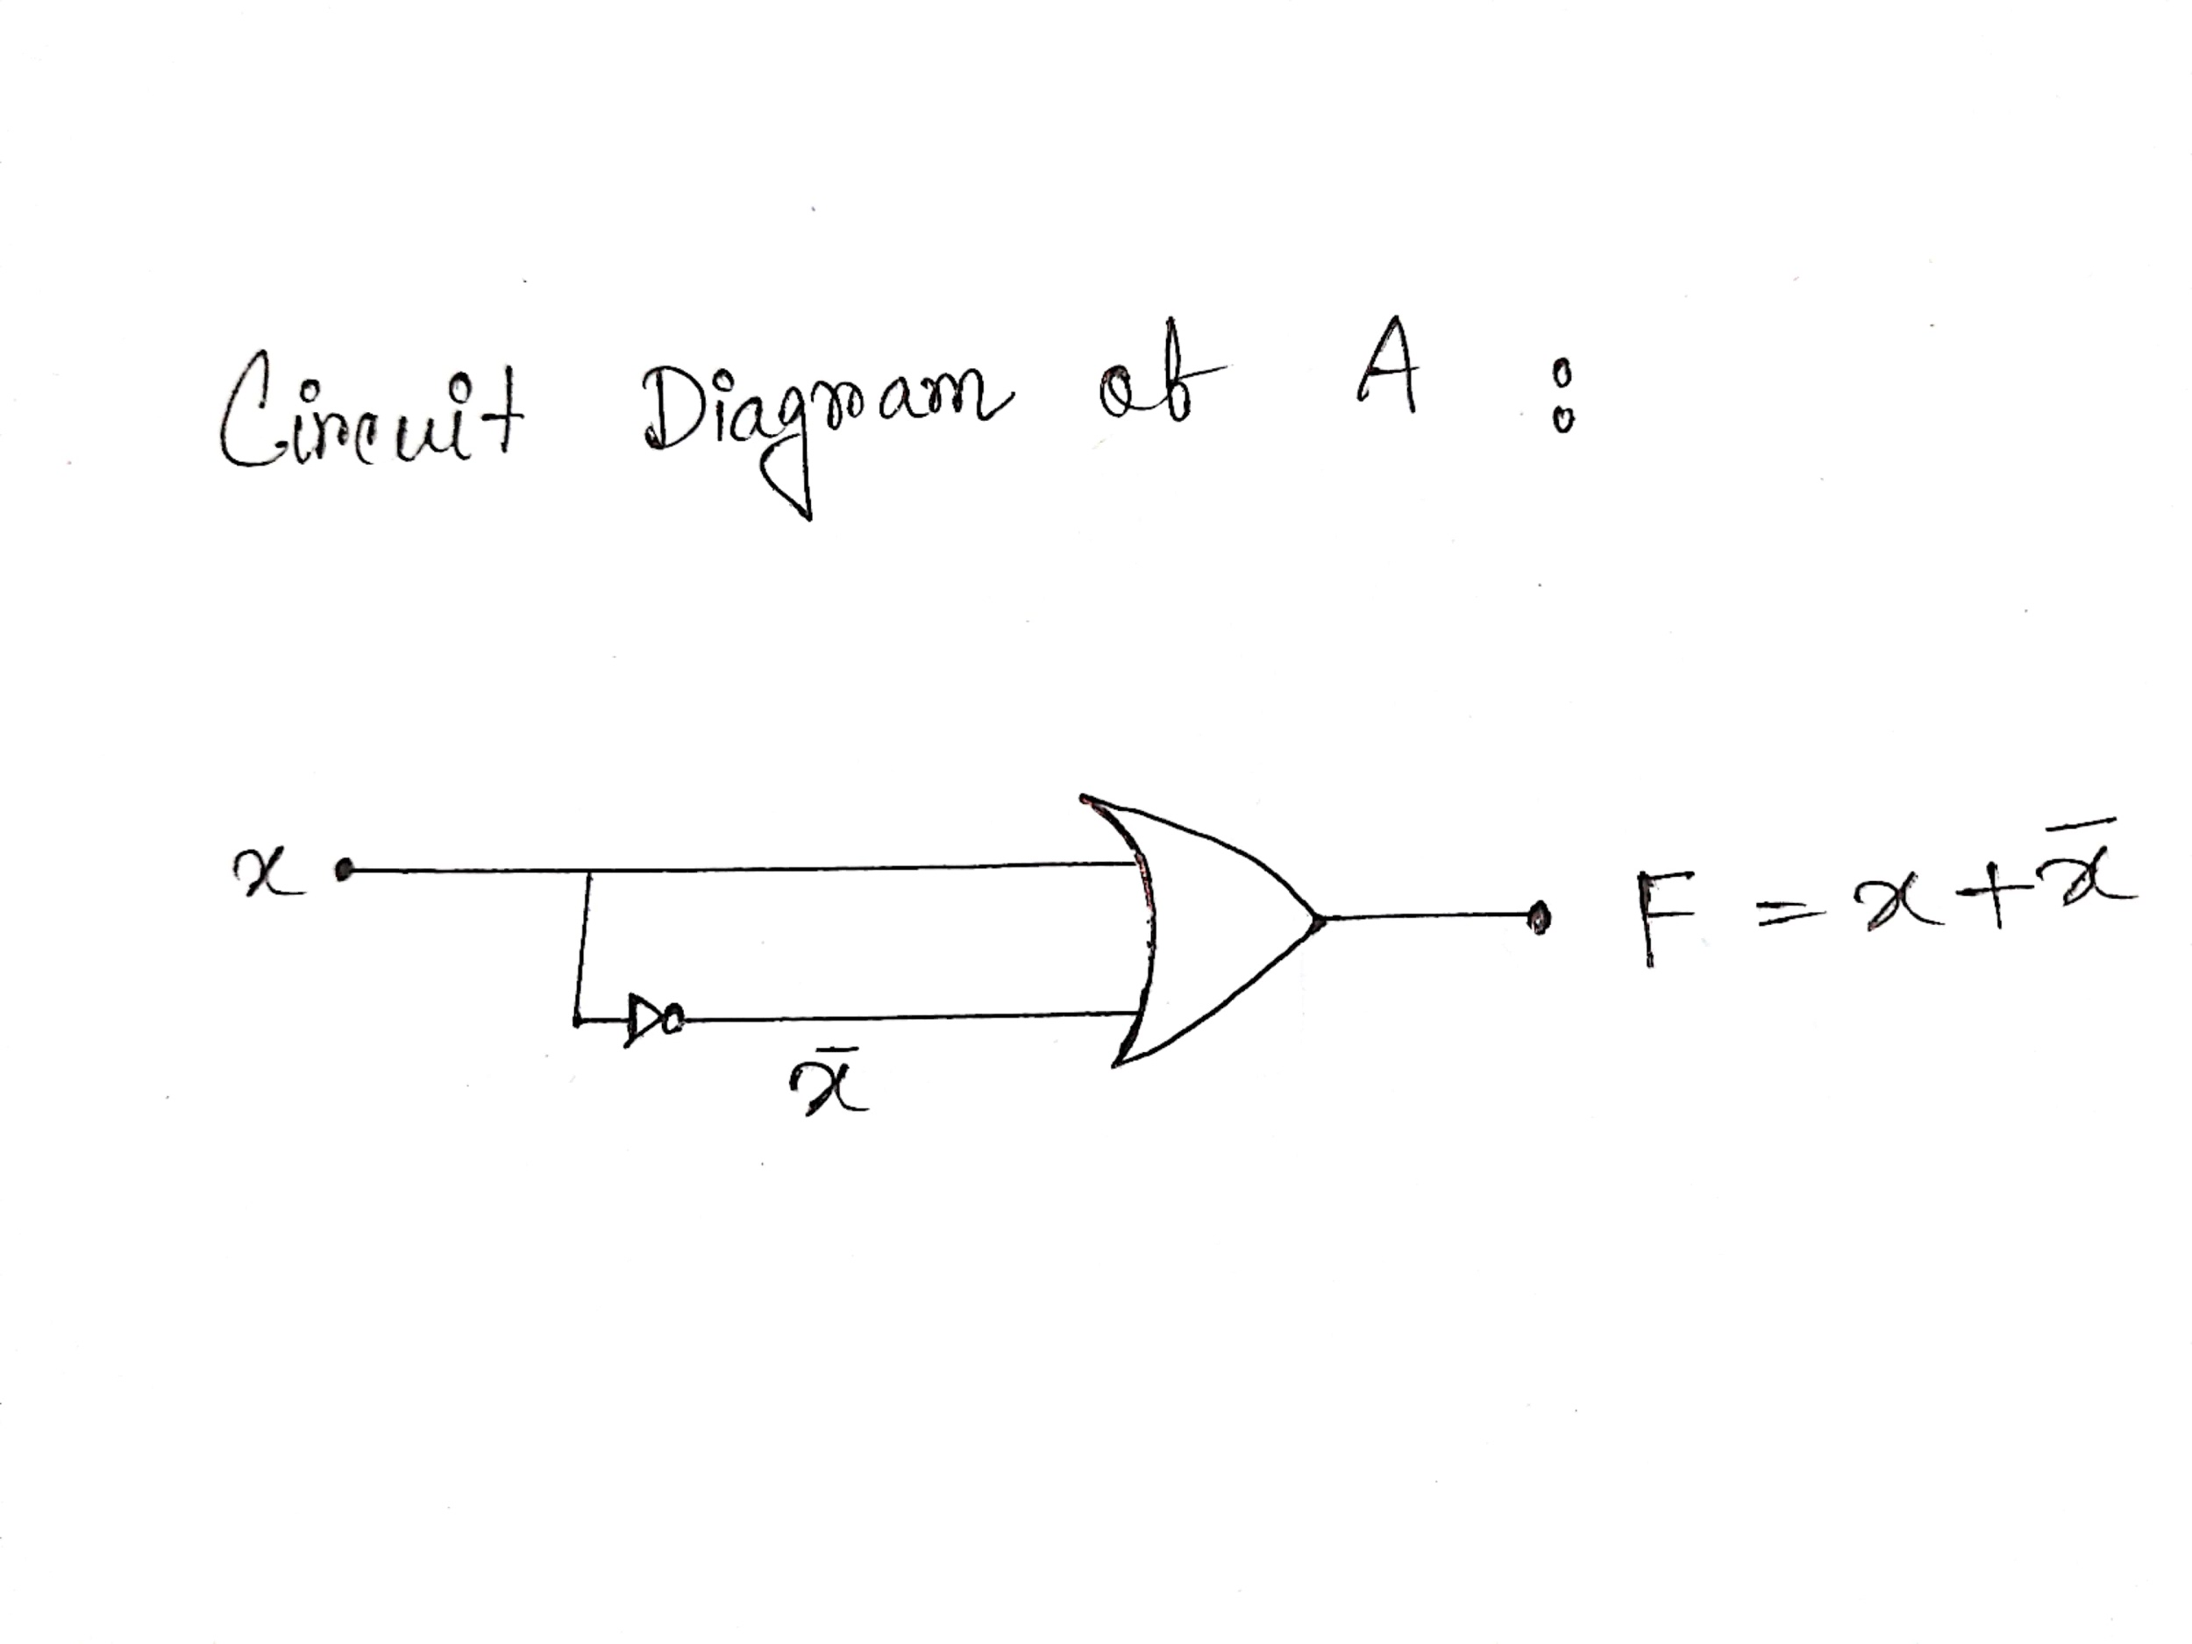  
  
  
  
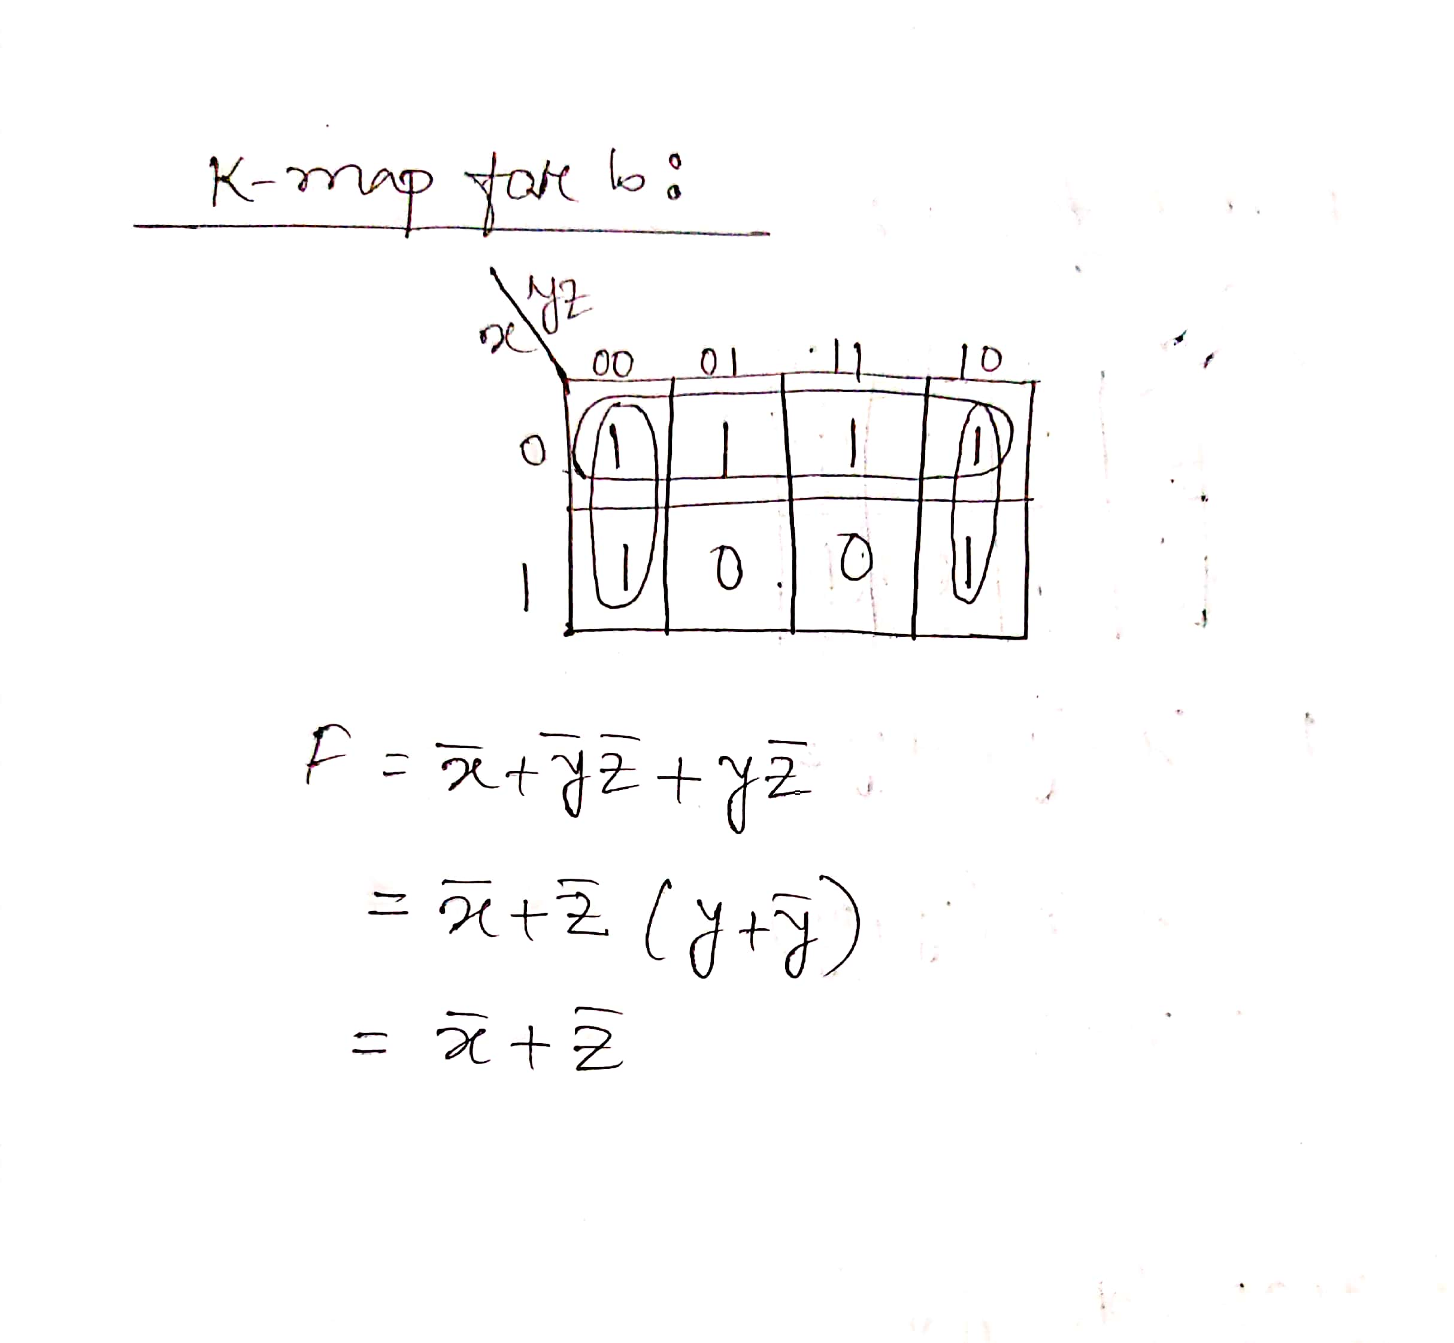  
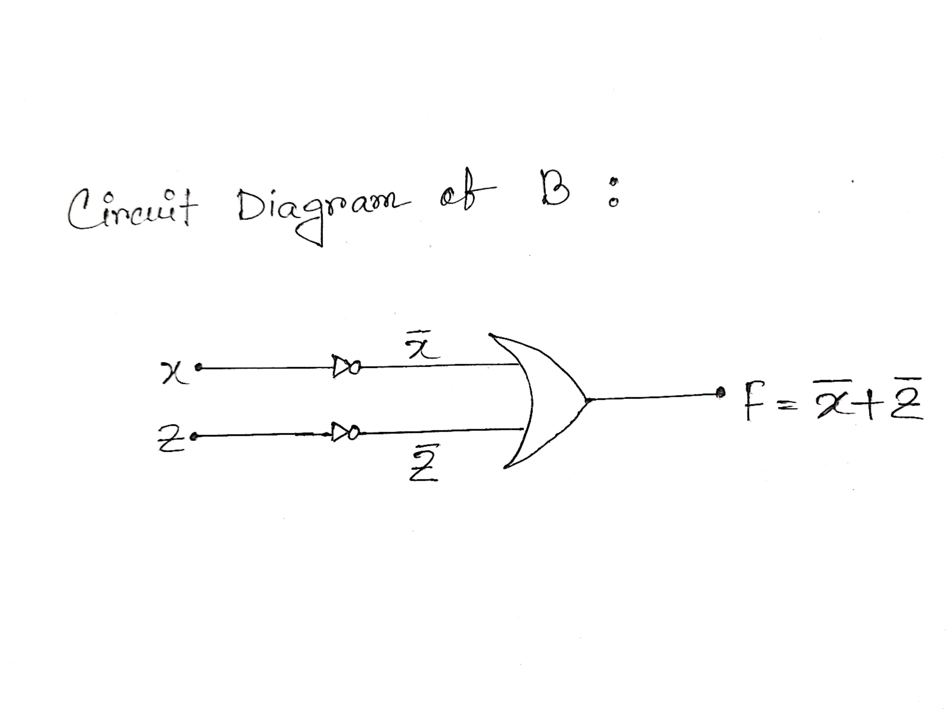  
  
  
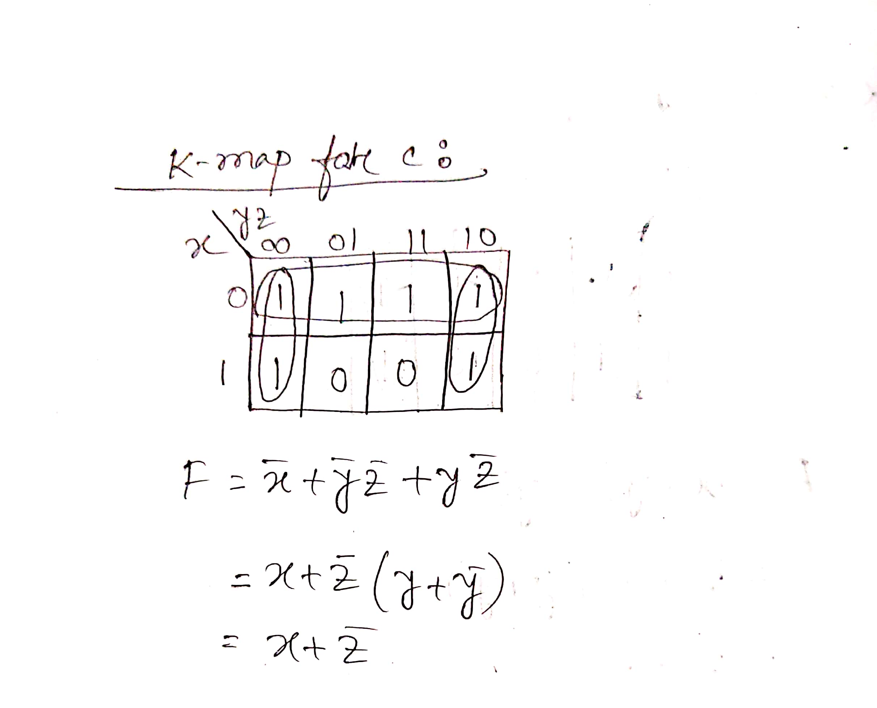  
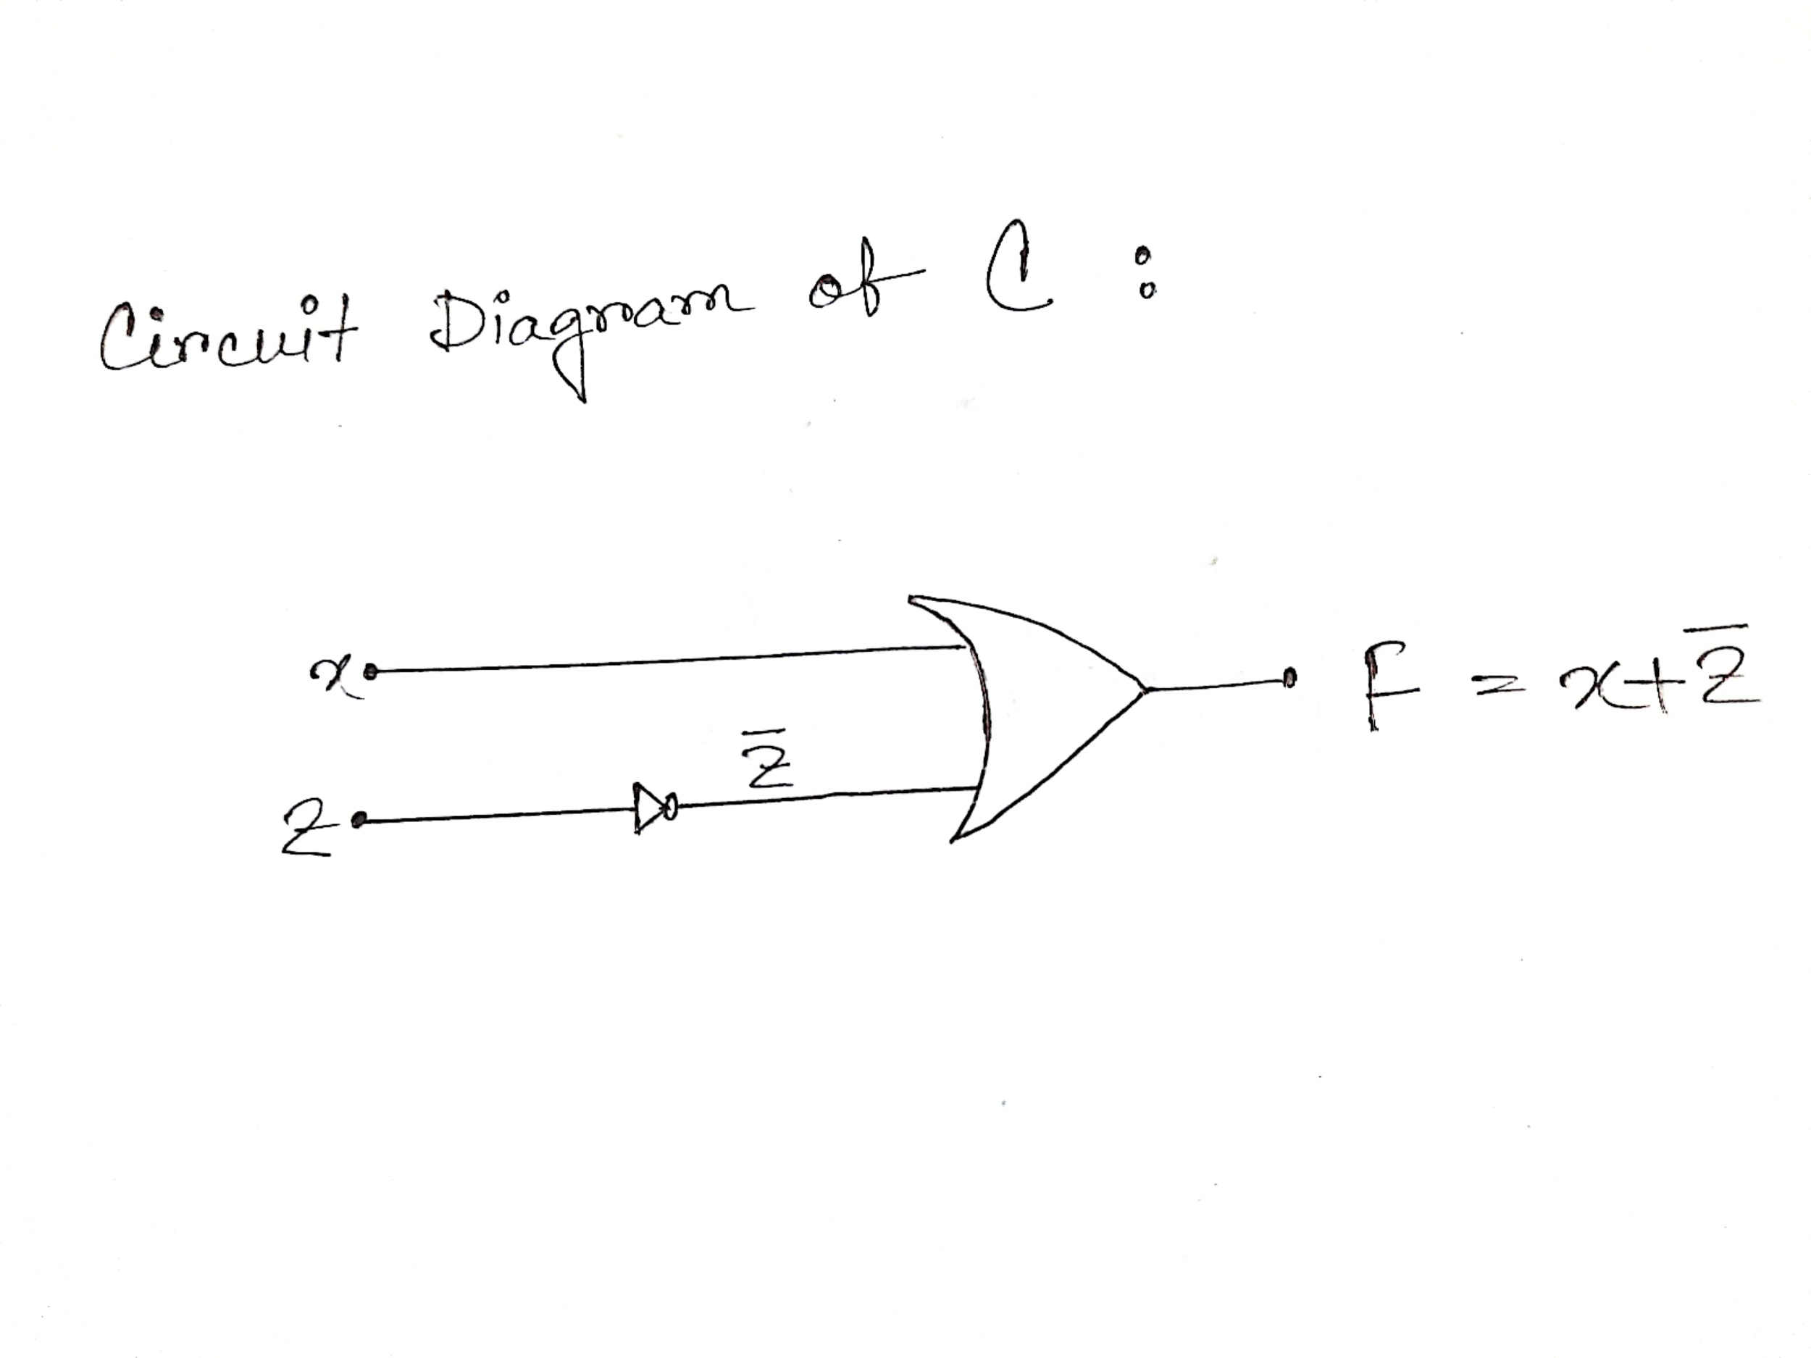  
  
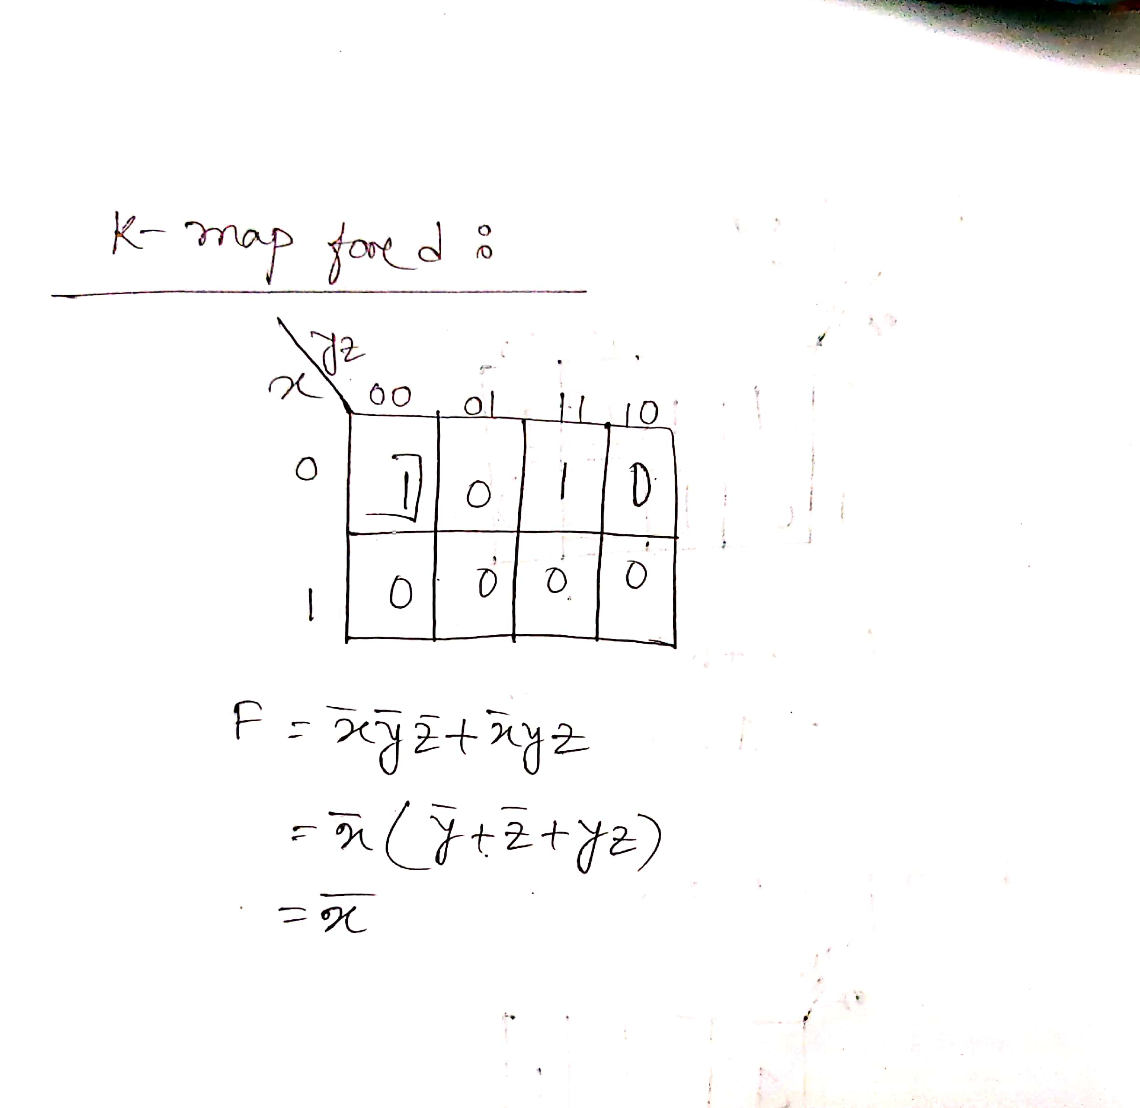  
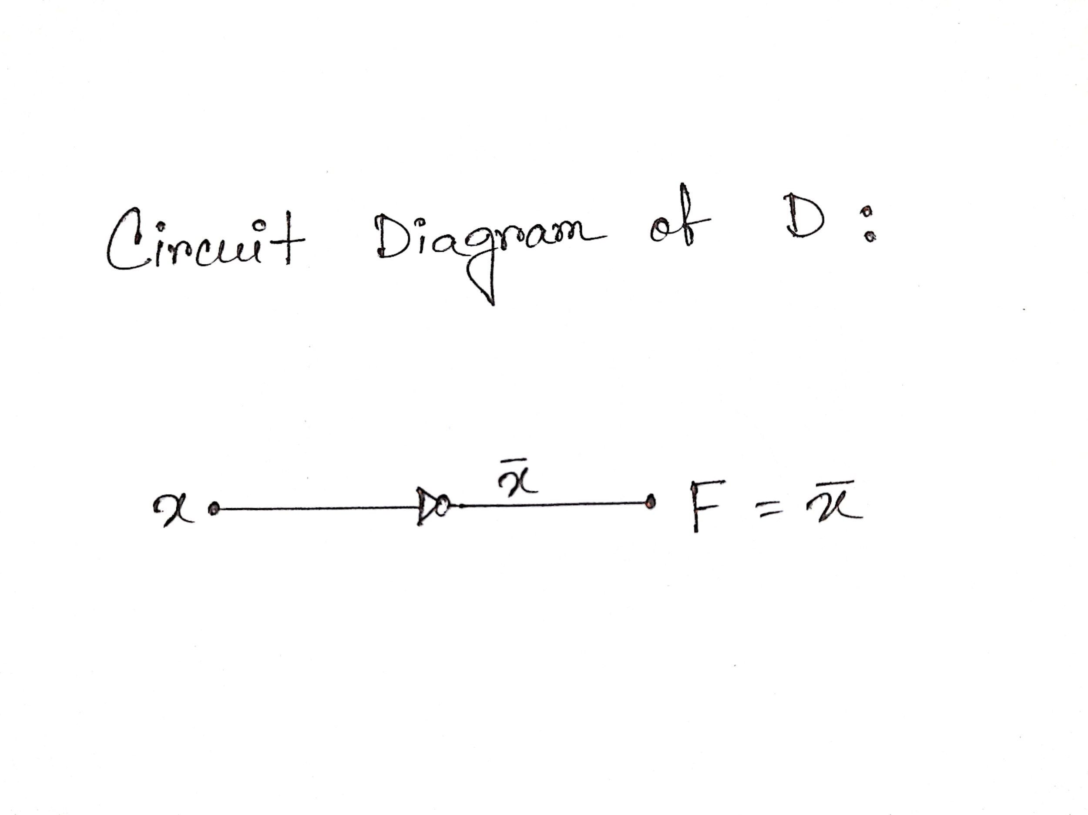  
  
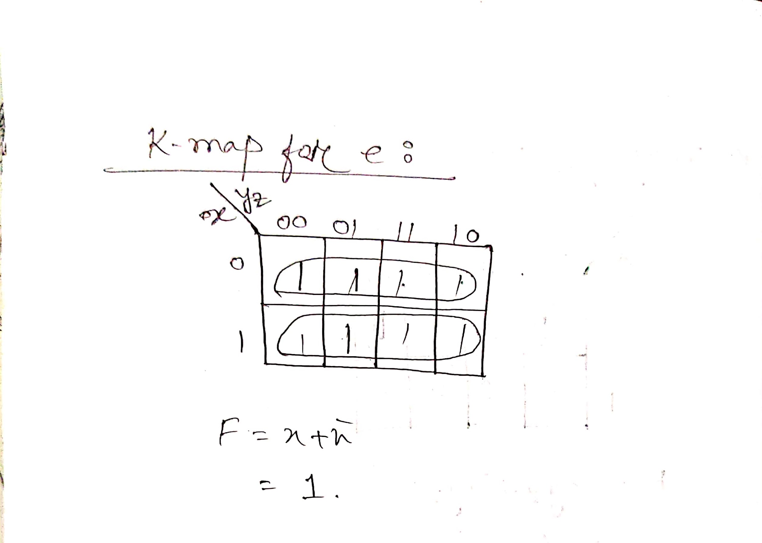  
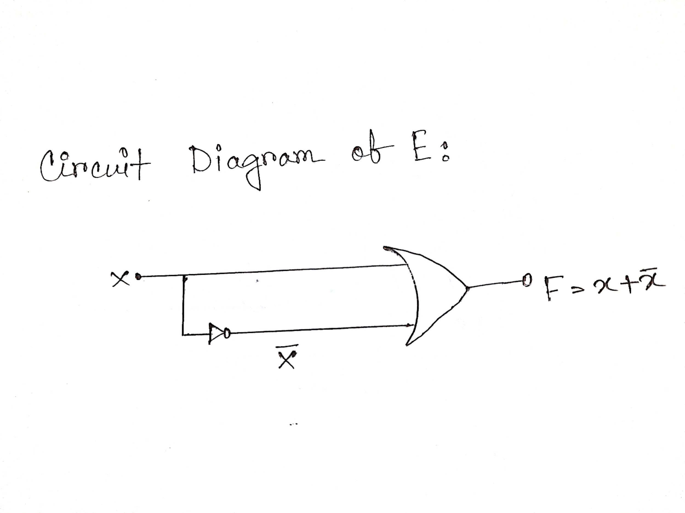  
  
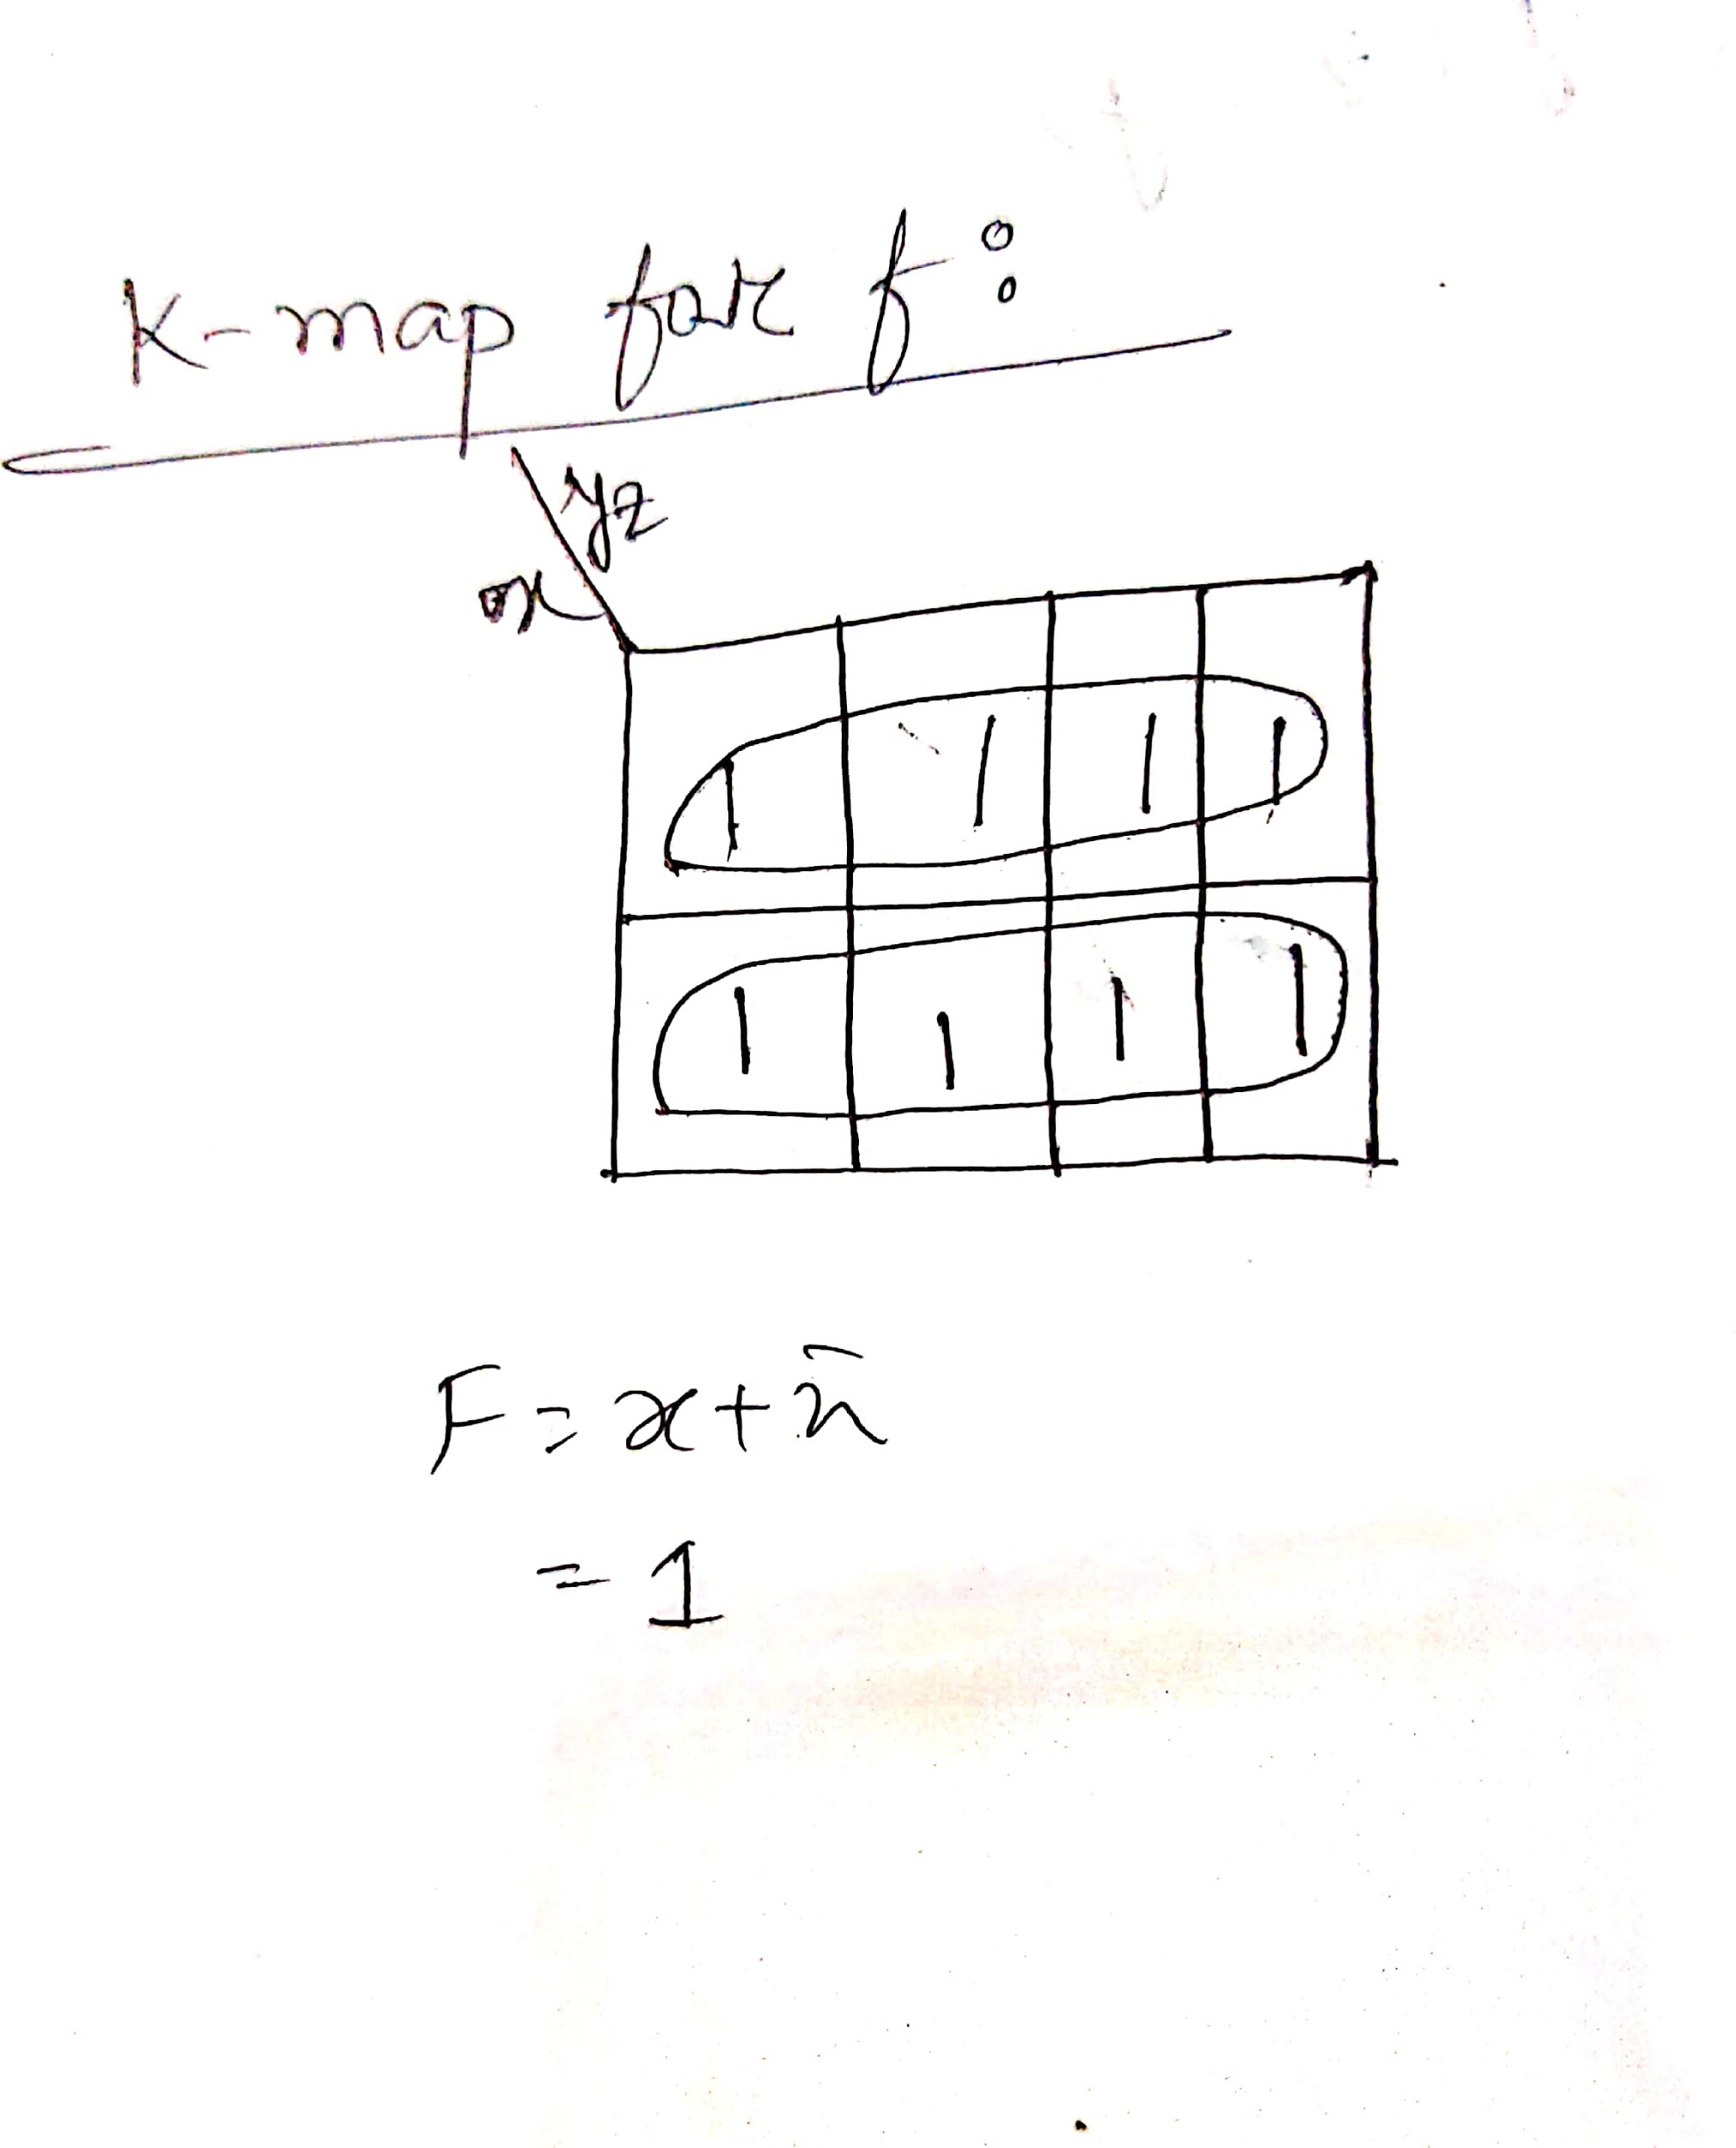  
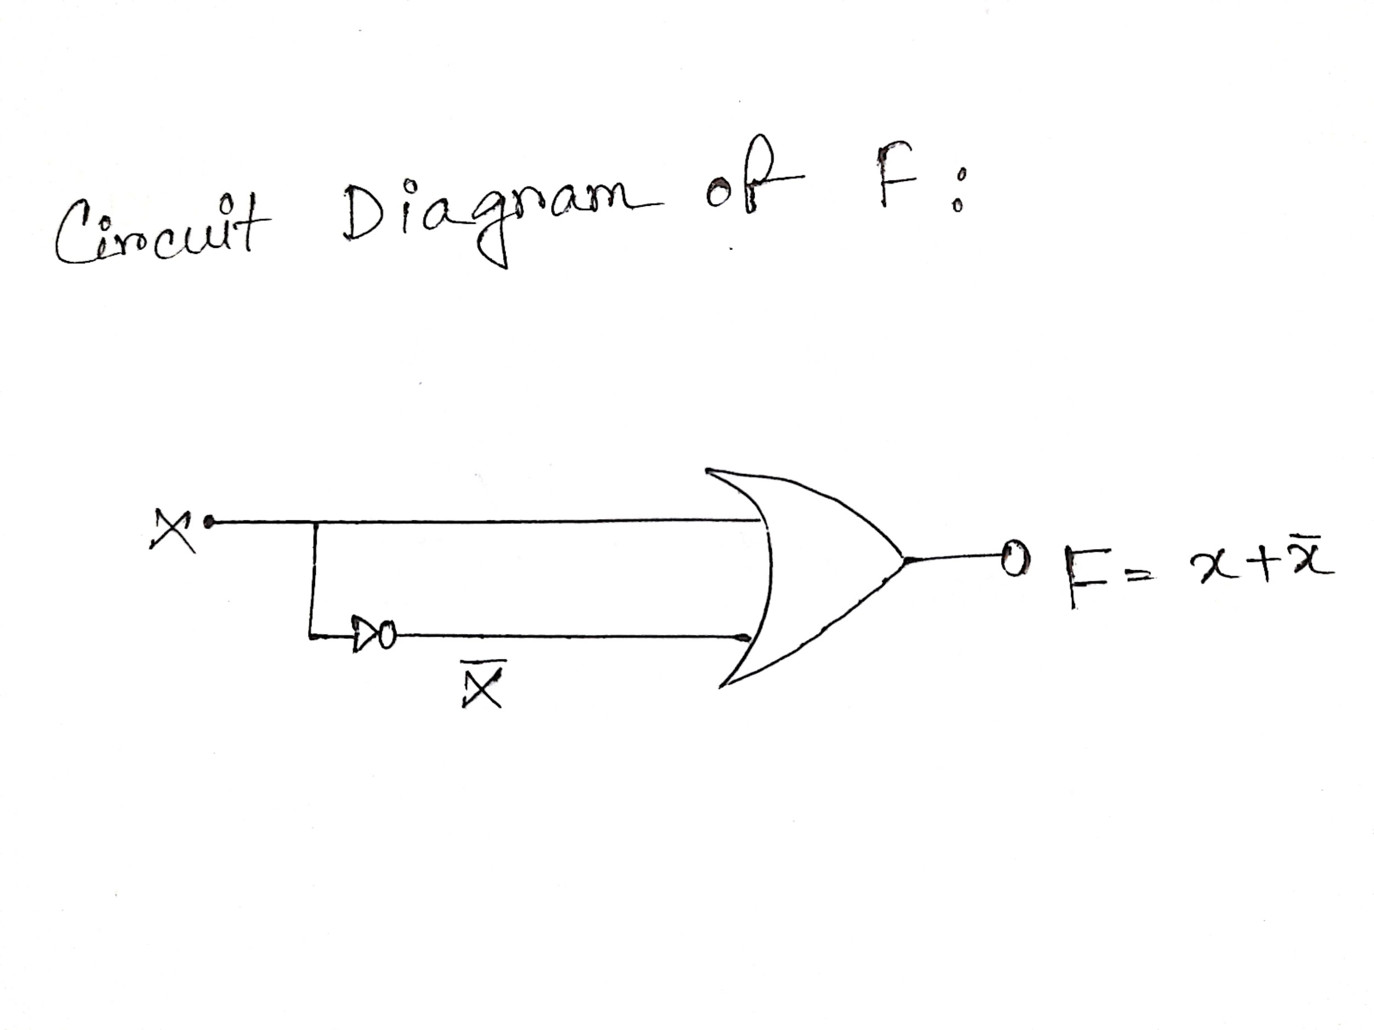  
  
  
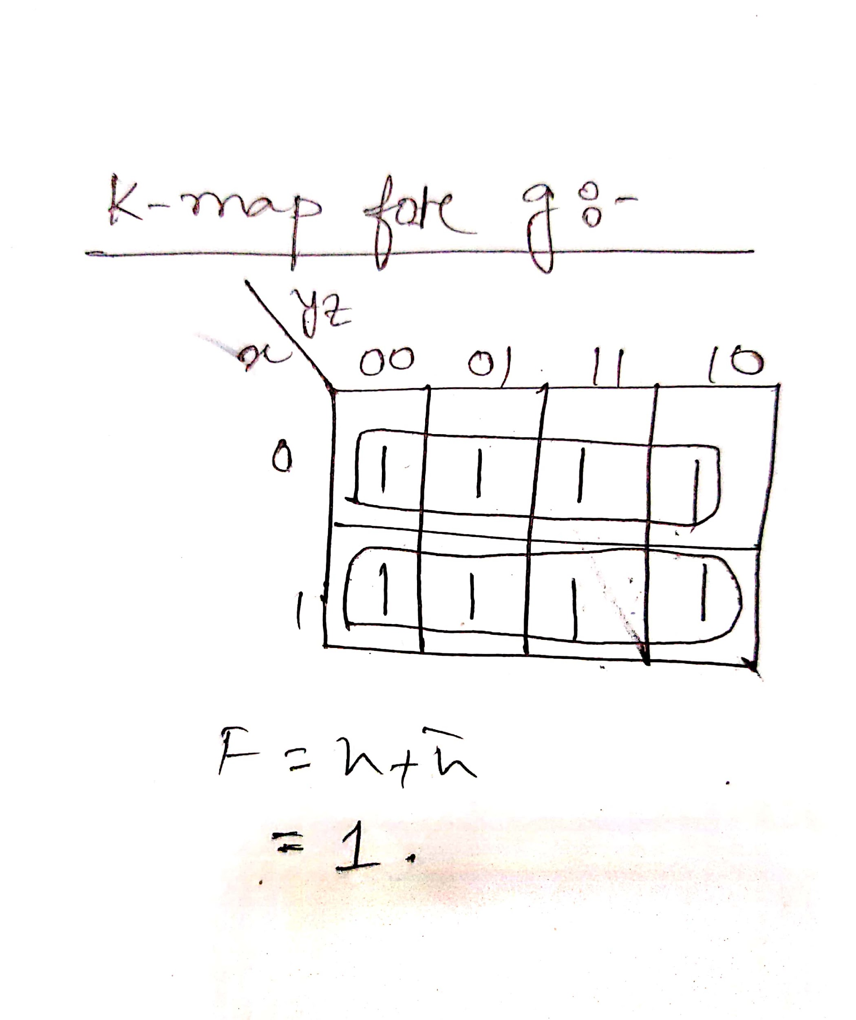  
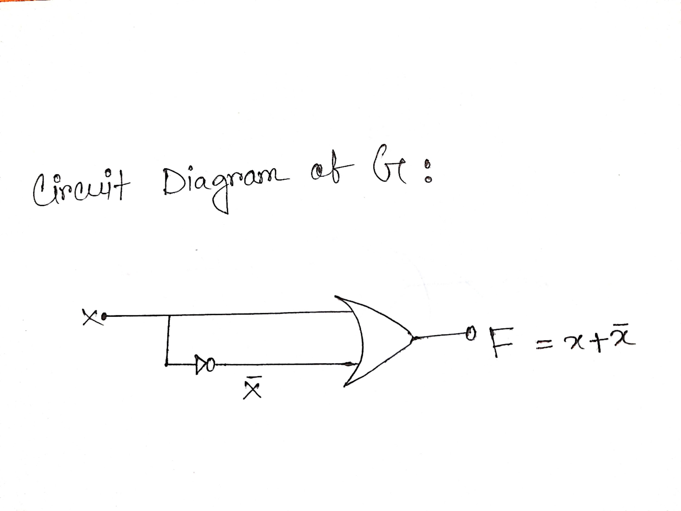  
  
Circuit Diagram On logisim:   
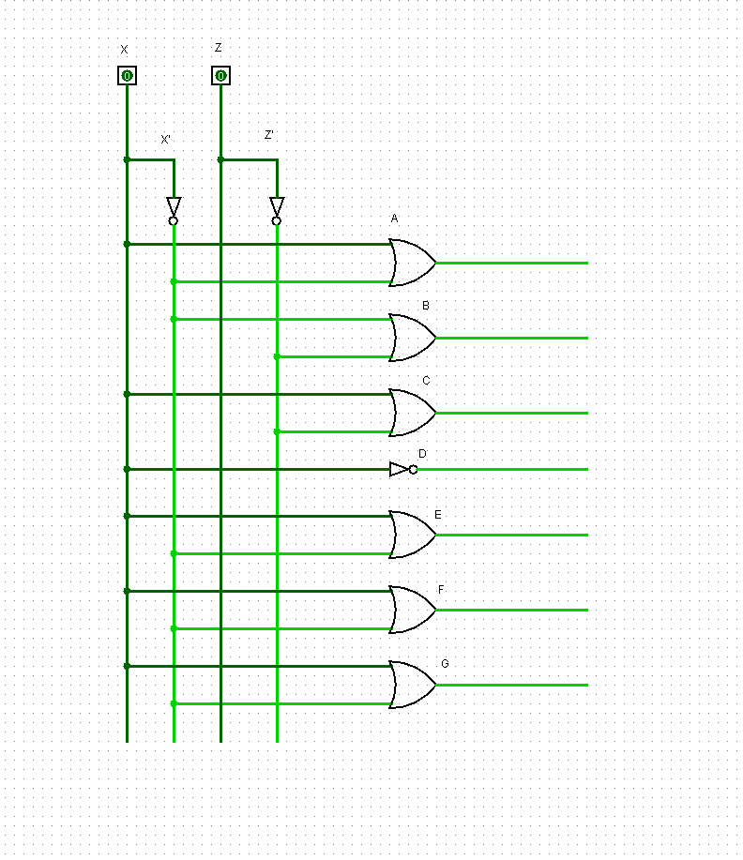  
  
 **Figure A.1**  
**Logisim: BABAFAFA  
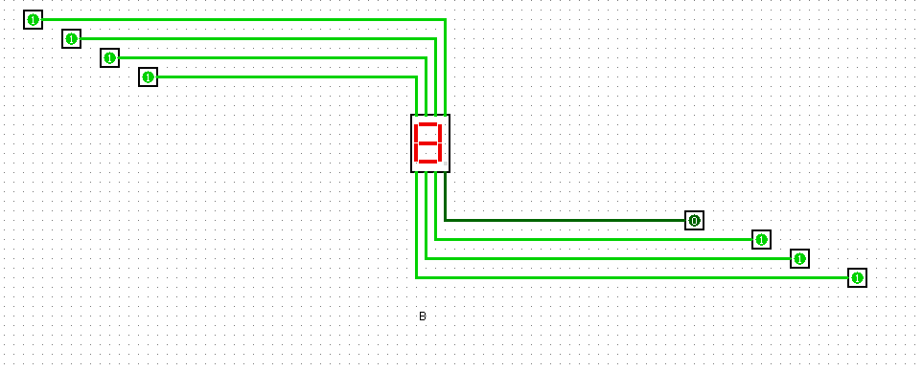  
 Figure B.1:B  
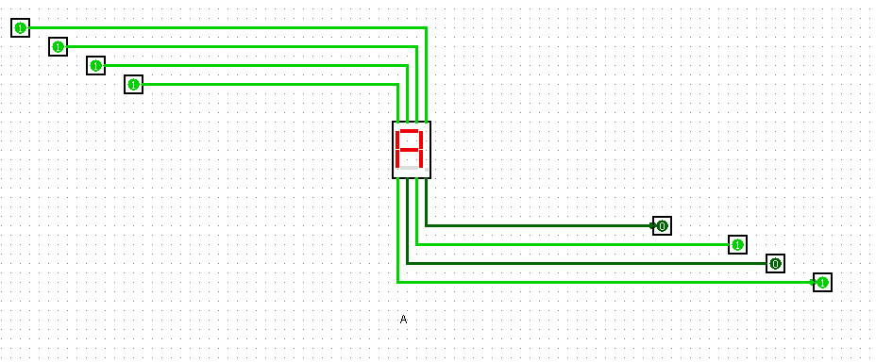  
  
 Figure B.2: A  
  
  
Figure B.3 : B  
  
  Figure B.4: A 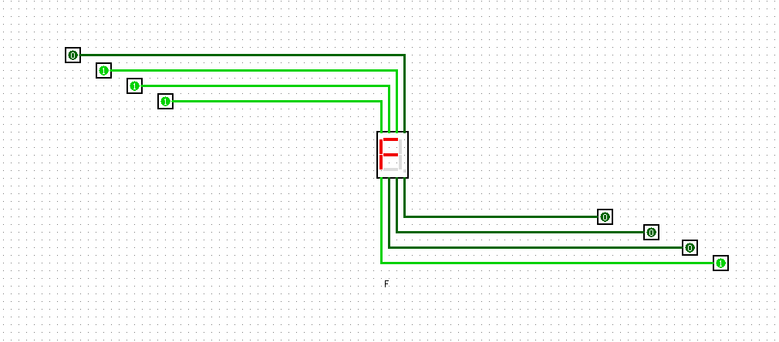   
 Figure B.5: F**

**  
Figure B.6: A**

**Figure B.7: F**

**  
Figure B.8: A  
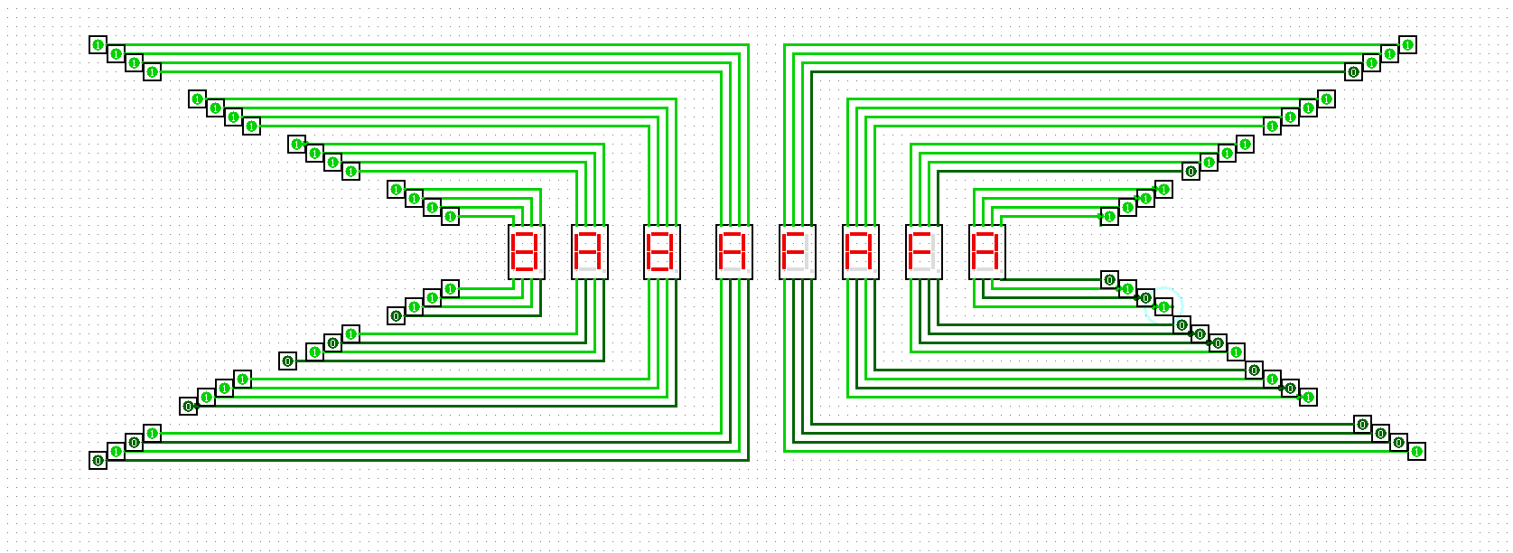  
 Figure B.9:** Final Output

